Name : Arshiya Tabassum A

Superset ID : 6424209

**WEEK 4**

**HTTP Request Response**

**Code :**

**Springlearnapplication.java**

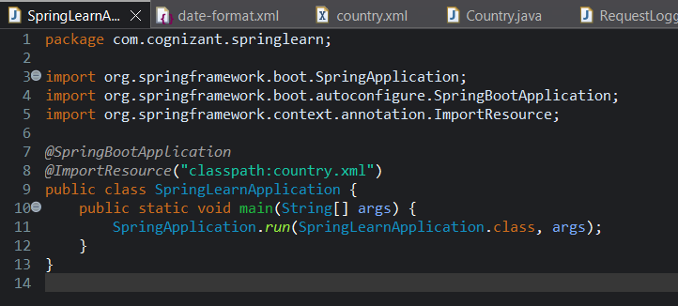

**RequestLogin.java**

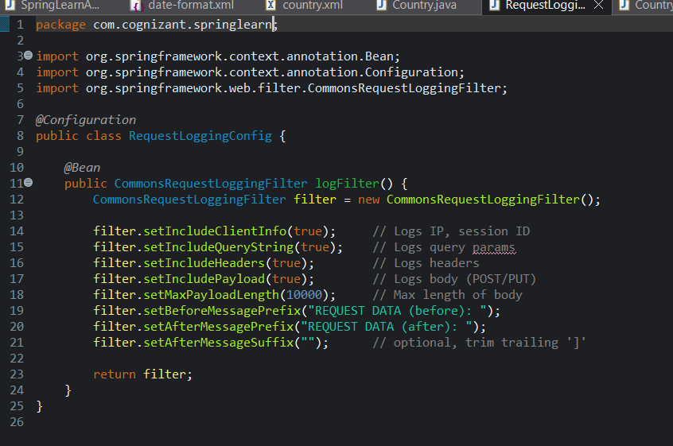

**CountryService.java**

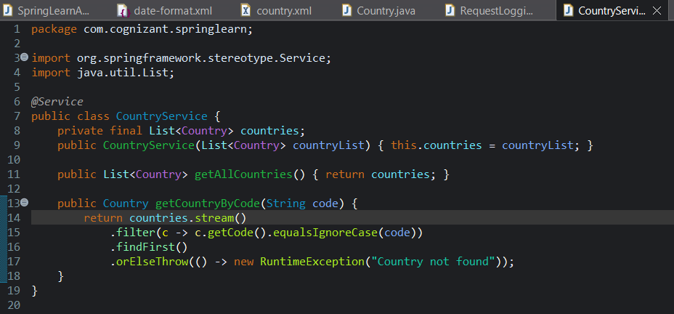

**CountryController.java**

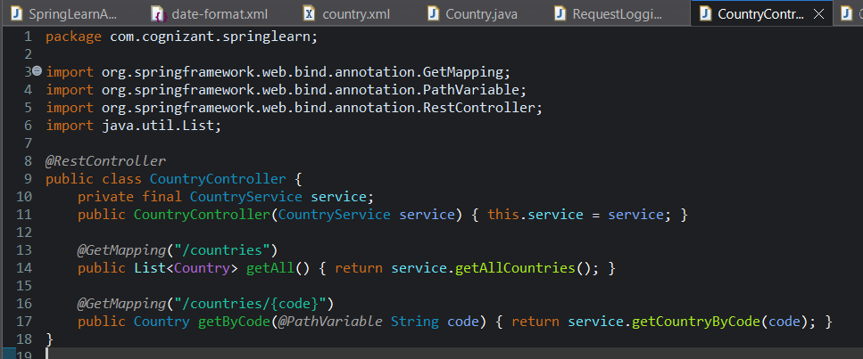

**Country.xml**

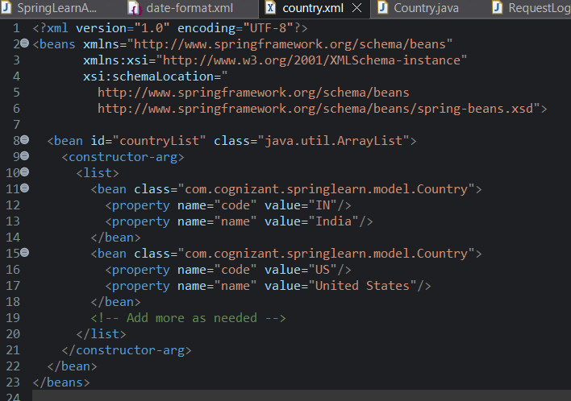

**Output :**

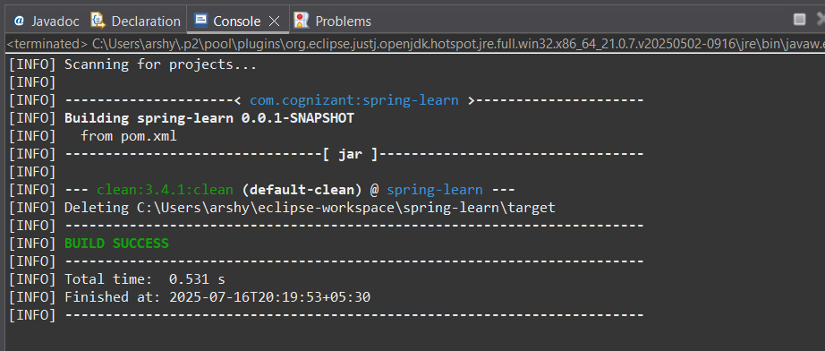

**Hello World RESTful Web Service   
Code :**

**SpringLearnapplication.java**

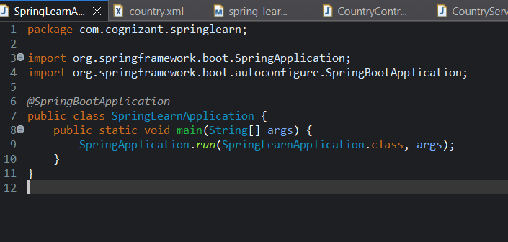

**HelloController.java**

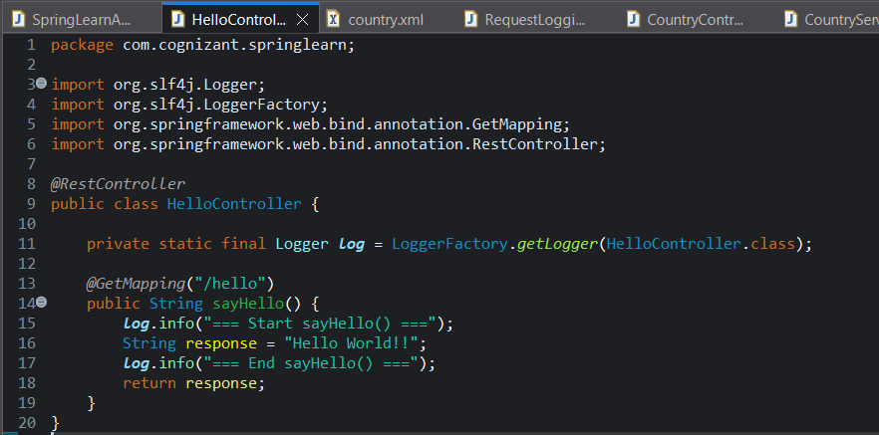

**Output :**

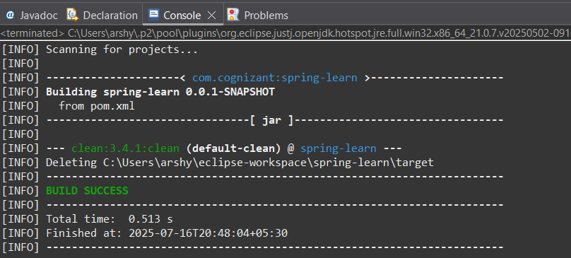

**REST - Country Web Service   
Code :**

**Country.java**

package com.cognizant.springlearn.model;

public class Country {

private String code;

private String name;

public Country() { }

public Country(String code, String name) {

this.code = code;

this.name = name;

}

public String getCode() {

return code;

}

public void setCode(String code) {

this.code = code;

}

public String getName() {

return name;

}

public void setName(String name) {

this.name = name;

}

}

**CountryController.java**

package com.cognizant.springlearn.controller;

import com.cognizant.springlearn.model.Country;

import com.cognizant.springlearn.service.CountryService;

import org.springframework.http.ResponseEntity;

import org.springframework.web.bind.annotation.*;

import java.util.List;

*@RestController*

*@RequestMapping*("/countries")

public class CountryController {

private final CountryService service;

public CountryController(CountryService service) {

this.service = service;

}

*@GetMapping*

public List<Country> getAll() {

return service.getAllCountries();

}

*@GetMapping*("/{code}")

public ResponseEntity<Country> getByCode(*@PathVariable* String code) {

Country c = service.getCountryByCode(code);

return c == null ? ResponseEntity.*notFound*().build() : ResponseEntity.*ok*(c);

}

}

**CountryService.java**

package com.cognizant.springlearn.service;

import com.cognizant.springlearn.model.Country;

import org.springframework.stereotype.Service;

import java.util.ArrayList;

import java.util.List;

*@Service*

public class CountryService {

private final List<Country> countries;

public CountryService() {

this.countries = new ArrayList<>();

countries.add(new Country("IN", "India"));

countries.add(new Country("US", "United States"));

}

public List<Country> getAllCountries() {

return countries;

}

public Country getCountryByCode(String code) {

return countries.stream()

.filter(c -> c.getCode().equalsIgnoreCase(code))

.findFirst()

.orElse(null);

}

}

**Output :**

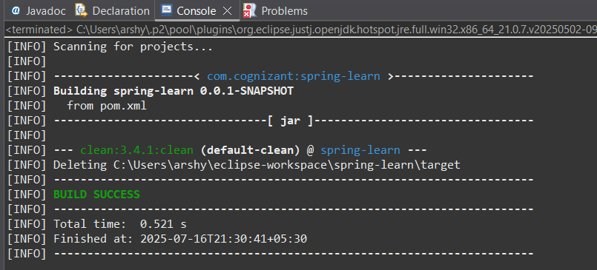

**clean install -DskipTests**

**Code :**

**Springlearnapplication.java**

package com.cognizant.springlearn;

import org.slf4j.Logger;

import org.slf4j.LoggerFactory;

import org.springframework.boot.SpringApplication;

import org.springframework.boot.autoconfigure.SpringBootApplication;

import org.springframework.context.support.ClassPathXmlApplicationContext;

import java.text.SimpleDateFormat;

import java.util.Date;

*@SpringBootApplication*

public class SpringLearnApplication {

private static final Logger ***LOGGER*** = LoggerFactory.*getLogger*(SpringLearnApplication.class);

public static void main(String[] args) {

***LOGGER***.info("Application START");

SpringApplication.*run*(SpringLearnApplication.class, args);

SpringLearnApplication app = new SpringLearnApplication();

app.displayDate();

***LOGGER***.info("Application END");

}

public void displayDate() {

***LOGGER***.info("displayDate START");

try (ClassPathXmlApplicationContext context =

new ClassPathXmlApplicationContext("date-format.xml")) {

SimpleDateFormat format = context.getBean("dateFormat", SimpleDateFormat.class);

Date date = format.parse("31/12/2018");

***LOGGER***.debug("Parsed Date: {}", date);

} catch (Exception e) {

***LOGGER***.error("Date parsing error", e);

}

***LOGGER***.info("displayDate END");

}

}

**CountryController.java**

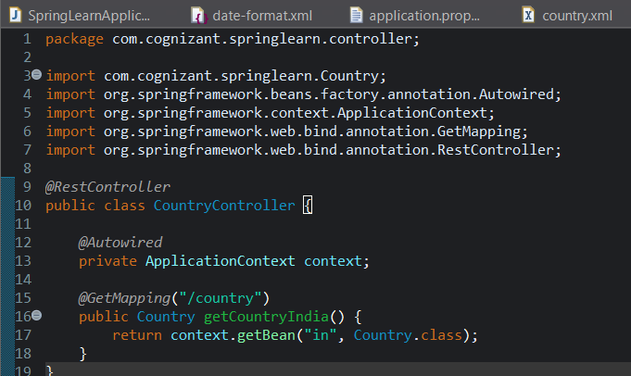

**Country.xml**

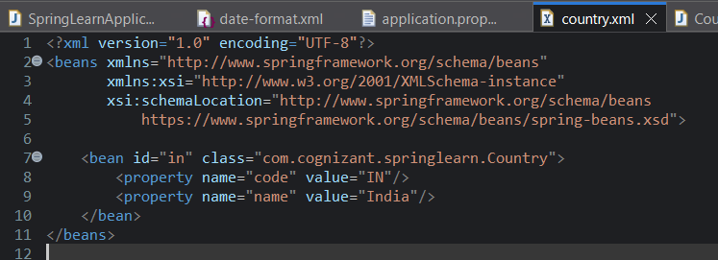

**Output :**

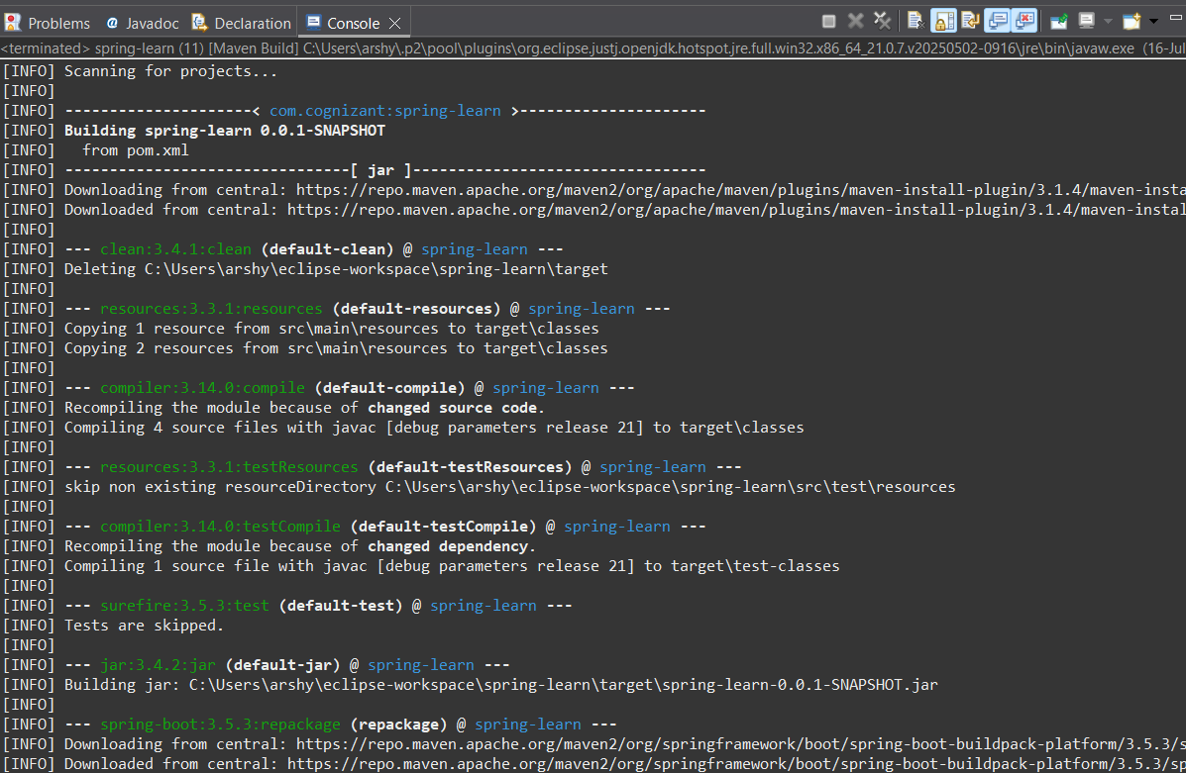

**REST - Get all countries**

**Code :**

**Springlearnapplication.java**

package com.cognizant.springlearn.controller;

import com.cognizant.springlearn.Country;

import org.springframework.beans.factory.annotation.Autowired;

import org.springframework.context.ApplicationContext;

import org.springframework.web.bind.annotation.GetMapping;

import org.springframework.web.bind.annotation.RestController;

@RestController

public class CountryController {

@Autowired

private ApplicationContext context;

@GetMapping("/country")

public Country getCountryIndia() {

// Retrieve the "in" bean defined in country.xml

return context.getBean("in", Country.class);

}

}

**Country.xml**

<?xml version="1.0" encoding="UTF-8"?>

<beans xmlns="http://www.springframework.org/schema/beans"

xmlns:xsi="http://www.w3.org/2001/XMLSchema-instance"

xsi:schemaLocation="

http://www.springframework.org/schema/beans

https://www.springframework.org/schema/beans/spring-beans.xsd">

<bean id="in" class="com.cognizant.springlearn.Country">

<property name="code" value="IN"/>

<property name="name" value="India"/>

</bean>

<bean id="us" class="com.cognizant.springlearn.Country">

<property name="code" value="US"/>

<property name="name" value="United States"/>

</bean>

<bean id="jp" class="com.cognizant.springlearn.Country">

<property name="code" value="JP"/>

<property name="name" value="Japan"/>

</bean>

<bean id="de" class="com.cognizant.springlearn.Country">

<property name="code" value="DE"/>

<property name="name" value="Germany"/>

</bean>

<bean id="countryList" class="java.util.ArrayList">

<constructor-arg>

<list>

<ref bean="in"/>

<ref bean="us"/>

<ref bean="jp"/>

<ref bean="de"/>

</list>

</constructor-arg>

</bean>

</beans>

**CountryController.java**

package com.cognizant.springlearn.controller;

import com.cognizant.springlearn.Country;

import org.springframework.beans.factory.annotation.Autowired;

import org.springframework.context.ApplicationContext;

import org.springframework.web.bind.annotation.GetMapping;

import org.springframework.web.bind.annotation.RestController;

*@RestController*

public class CountryController {

*@Autowired*

private ApplicationContext context;

*@GetMapping*("/country")

public Country getCountryIndia() {

// Retrieve the "in" bean defined in country.xml

return context.getBean("in", Country.class);

}

}

**Output :**

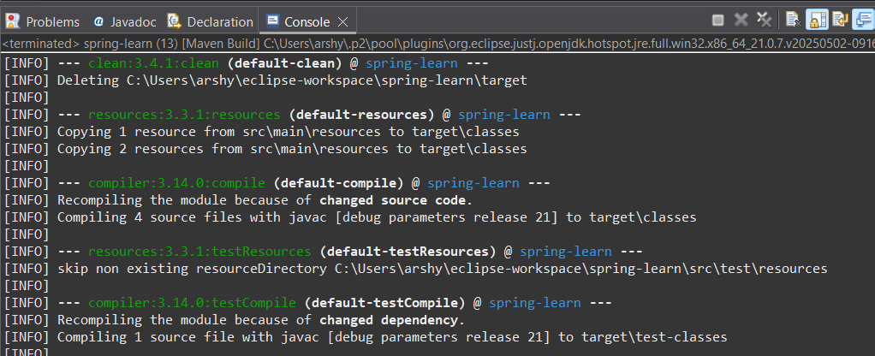

**REST - Get country based on country code**

**Code :**

**Springlearnapplication.java**

package com.cognizant.springlearn;

import org.slf4j.Logger;

import org.slf4j.LoggerFactory;

import org.springframework.beans.factory.annotation.Autowired;

import org.springframework.boot.CommandLineRunner;

import org.springframework.boot.SpringApplication;

import org.springframework.boot.autoconfigure.SpringBootApplication;

import org.springframework.context.ApplicationContext;

import org.springframework.context.annotation.ImportResource;

import java.text.SimpleDateFormat;

import java.util.Date;

*@SpringBootApplication*

*@ImportResource*("classpath:date-format.xml")

public class SpringLearnApplication implements CommandLineRunner {

private static final Logger ***LOGGER*** = LoggerFactory.*getLogger*(SpringLearnApplication.class);

*@Autowired*

private ApplicationContext context;

public static void main(String[] args) {

SpringApplication.*run*(SpringLearnApplication.class, args);

}

*@Override*

public void run(String... args) {

***LOGGER***.info("Application START");

// Use a bean defined in date‑format.xml

displayDate();

***LOGGER***.info("Application END");

}

private void displayDate() {

***LOGGER***.info("displayDate START");

try {

SimpleDateFormat format = context.getBean("dateFormat", SimpleDateFormat.class);

Date date = format.parse("31/12/2018");

***LOGGER***.debug("Parsed Date: {}", date);

} catch (Exception e) {

***LOGGER***.error("Date parsing error", e);

}

***LOGGER***.info("displayDate END");

}

}

**CountryService.java**

package com.cognizant.springlearn.service;

import com.cognizant.springlearn.Country;

import org.springframework.beans.factory.annotation.Autowired;

import org.springframework.context.ApplicationContext;

import org.springframework.stereotype.Service;

import java.util.List;

*@Service*

public class CountryService {

*@Autowired*

private ApplicationContext context;

*@SuppressWarnings*("unchecked")

public Country getCountry(String code) {

List<Country> countries = (List<Country>) context.getBean("countryList");

return countries.stream()

.filter(c -> c.getCode().equalsIgnoreCase(code))

.findFirst()

.orElse(null);

}

}

**CountryController.java**

package com.cognizant.springlearn.controller;

import com.cognizant.springlearn.Country;

import org.springframework.beans.factory.annotation.Autowired;

import org.springframework.context.ApplicationContext;

import org.springframework.web.bind.annotation.GetMapping;

import org.springframework.web.bind.annotation.RestController;

*@RestController*

public class CountryController {

*@Autowired*

private ApplicationContext context;

*@GetMapping*("/country")

public Country getCountryIndia() {

// Retrieve the "in" bean defined in country.xml

return context.getBean("in", Country.class);

}

}

**Output :**

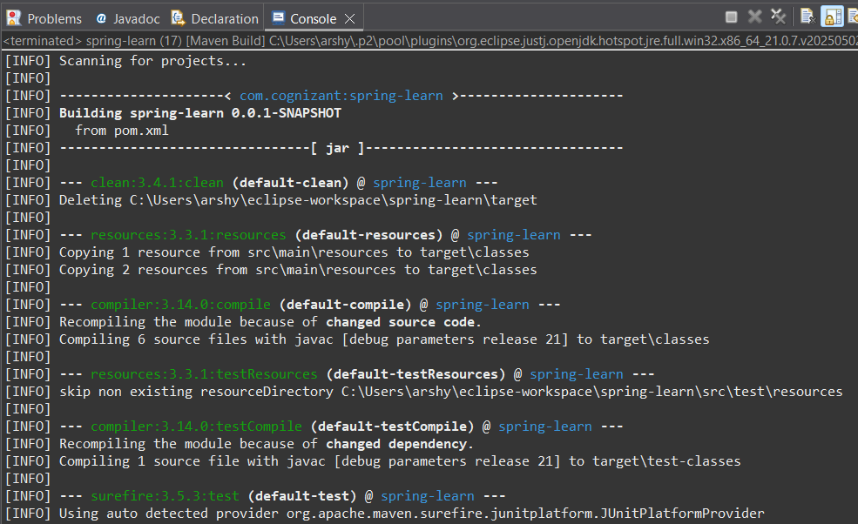

**REST - Get country exceptional scenario**

**Code :**

**Springlearnapplication.java**

package com.cognizant.springlearn;

import org.slf4j.Logger;

import org.slf4j.LoggerFactory;

import org.springframework.boot.SpringApplication;

import org.springframework.boot.autoconfigure.SpringBootApplication;

import org.springframework.context.support.ClassPathXmlApplicationContext;

import java.text.SimpleDateFormat;

import java.util.Date;

*@SpringBootApplication*

public class SpringLearnApplication {

private static final Logger ***LOGGER*** = LoggerFactory.*getLogger*(SpringLearnApplication.class);

public static void main(String[] args) {

***LOGGER***.info("Application START");

SpringApplication.*run*(SpringLearnApplication.class, args);

new SpringLearnApplication().displayDate();

***LOGGER***.info("Application END");

}

public void displayDate() {

***LOGGER***.info("displayDate START");

try (ClassPathXmlApplicationContext context =

new ClassPathXmlApplicationContext("date-format.xml")) {

SimpleDateFormat format = context.getBean("dateFormat", SimpleDateFormat.class);

// ensure non-lenient if needed:

format.setLenient(false);

Date date = format.parse("31/12/2018");

***LOGGER***.debug("Parsed Date: {}", date);

} catch (Exception e) {

***LOGGER***.error("Date parsing error", e);

}

***LOGGER***.info("displayDate END");

}

}

**date-format.xml**

<?xml version="1.0" encoding="UTF-8"?>

<beans xmlns="http://www.springframework.org/schema/beans"

xmlns:xsi="http://www.w3.org/2001/XMLSchema-instance"

xsi:schemaLocation="

http://www.springframework.org/schema/beans

http://www.springframework.org/schema/beans/spring-beans.xsd">

<bean id="dateFormat" class="java.text.SimpleDateFormat">

<constructor-arg value="dd/MM/yyyy"/>

</bean>

</beans>

**Output :**

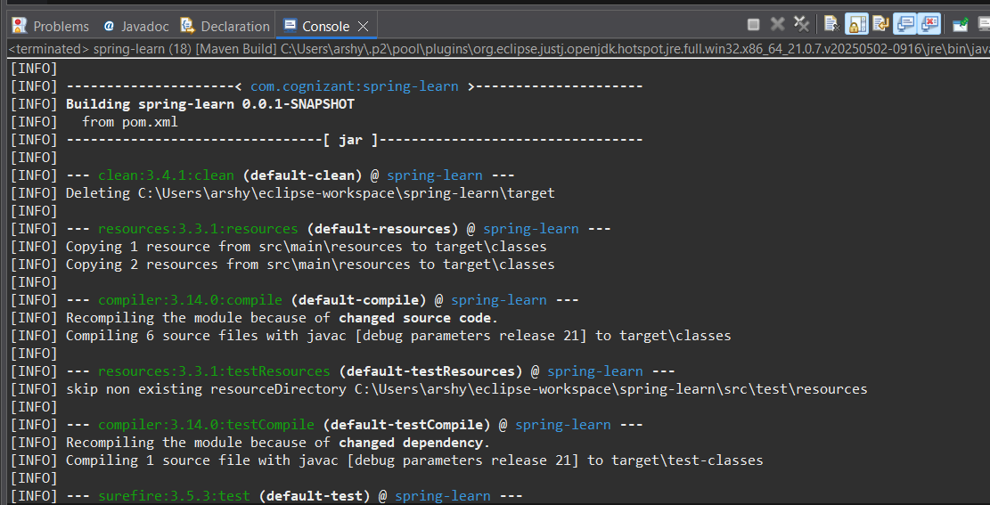

**MockMVC - Test get country service**

**SpringLearnTests.java**

<?xml version="1.0" encoding="UTF-8"?>

<project xmlns="http://maven.apache.org/POM/4.0.0"

xmlns:xsi="http://www.w3.org/2001/XMLSchema-instance"

xsi:schemaLocation="http://maven.apache.org/POM/4.0.0

https://maven.apache.org/xsd/maven-4.0.0.xsd">

<modelVersion>4.0.0</modelVersion>

<parent>

<groupId>org.springframework.boot</groupId>

<artifactId>spring-boot-starter-parent</artifactId>

<version>3.5.3</version>

<relativePath/>

</parent>

<groupId>com.cognizant</groupId>

<artifactId>spring-learn</artifactId>

<version>0.0.1-SNAPSHOT</version>

<properties>

<java.version>21</java.version>

</properties>

<dependencies>

<!-- Spring Web -->

<dependency>

<groupId>org.springframework.boot</groupId>

<artifactId>spring-boot-starter-web</artifactId>

</dependency>

<!-- Dev tools -->

<dependency>

<groupId>org.springframework.boot</groupId>

<artifactId>spring-boot-devtools</artifactId>

<scope>runtime</scope>

<optional>true</optional>

</dependency>

<!-- Testing -->

<dependency>

<groupId>org.springframework.boot</groupId>

<artifactId>spring-boot-starter-test</artifactId>

<scope>test</scope>

</dependency>

</dependencies>

<build>

<plugins>

<!-- Ensure JUnit‑5 is used -->

<plugin>

<groupId>org.apache.maven.plugins</groupId>

<artifactId>maven-surefire-plugin</artifactId>

<version>3.0.0-M9</version>

<configuration>

<useModulePath>false</useModulePath>

</configuration>

</plugin>

<!-- Spring Boot Maven support -->

<plugin>

<groupId>org.springframework.boot</groupId>

<artifactId>spring-boot-maven-plugin</artifactId>

</plugin>

</plugins>

</build>

</project>

**Pom.xml**

<?xml version="1.0" encoding="UTF-8"?>

<project xmlns="http://maven.apache.org/POM/4.0.0"

xmlns:xsi="http://www.w3.org/2001/XMLSchema-instance"

xsi:schemaLocation="http://maven.apache.org/POM/4.0.0

https://maven.apache.org/xsd/maven-4.0.0.xsd">

<modelVersion>4.0.0</modelVersion>

<parent>

<groupId>org.springframework.boot</groupId>

<artifactId>spring-boot-starter-parent</artifactId>

<version>3.5.3</version>

<relativePath/>

</parent>

<groupId>com.cognizant</groupId>

<artifactId>spring-learn</artifactId>

<version>0.0.1-SNAPSHOT</version>

<properties>

<java.version>21</java.version>

</properties>

<dependencies>

<!-- Spring Web -->

<dependency>

<groupId>org.springframework.boot</groupId>

<artifactId>spring-boot-starter-web</artifactId>

</dependency>

<!-- Dev tools -->

<dependency>

<groupId>org.springframework.boot</groupId>

<artifactId>spring-boot-devtools</artifactId>

<scope>runtime</scope>

<optional>true</optional>

</dependency>

<!-- Testing -->

<dependency>

<groupId>org.springframework.boot</groupId>

<artifactId>spring-boot-starter-test</artifactId>

<scope>test</scope>

</dependency>

</dependencies>

<build>

<plugins>

<!-- Ensure JUnit‑5 is used -->

<plugin>

<groupId>org.apache.maven.plugins</groupId>

<artifactId>maven-surefire-plugin</artifactId>

<version>3.0.0-M9</version>

<configuration>

<useModulePath>false</useModulePath>

</configuration>

</plugin>

<!-- Spring Boot Maven support -->

<plugin>

<groupId>org.springframework.boot</groupId>

<artifactId>spring-boot-maven-plugin</artifactId>

</plugin>

</plugins>

</build>

</project>

**Output :**

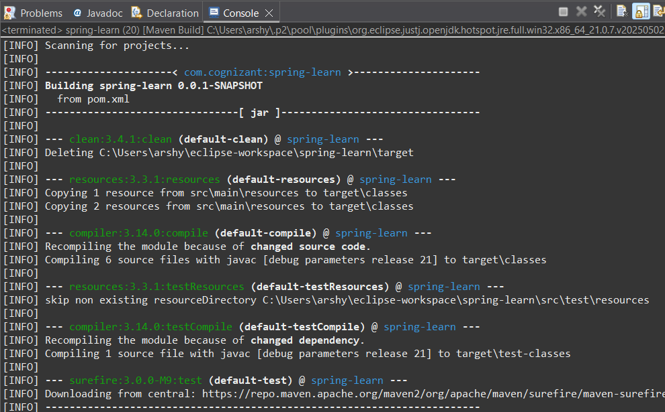

**MockMVC - Test get country service for exceptional scenario**

**Code :**

**Countrycontroller.java**

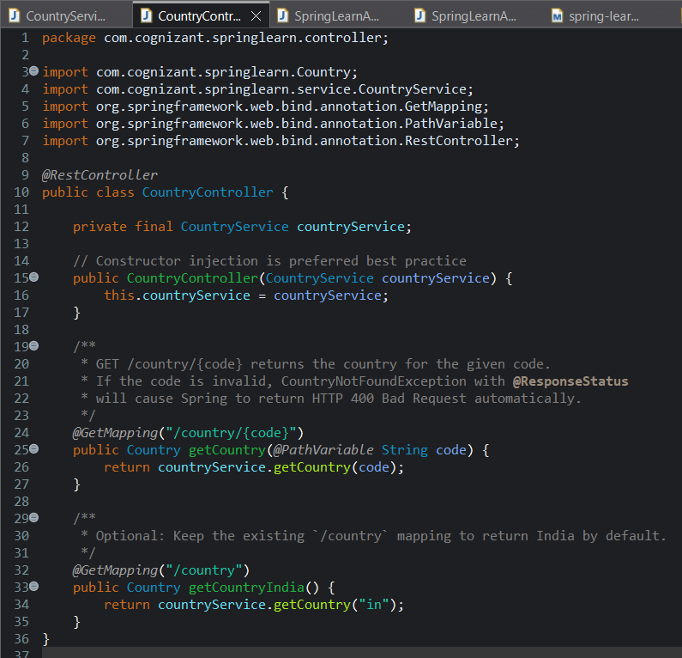

**CountryNotFound**

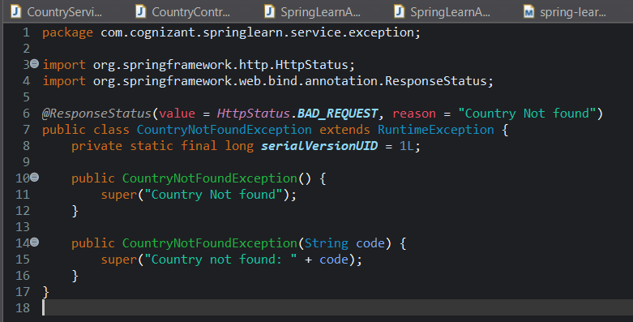

**Country.xml**

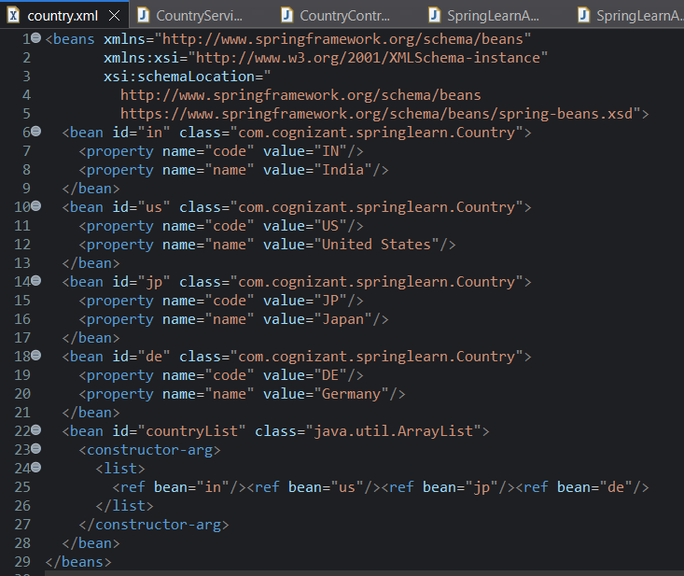

**SpringLearnTest.java**

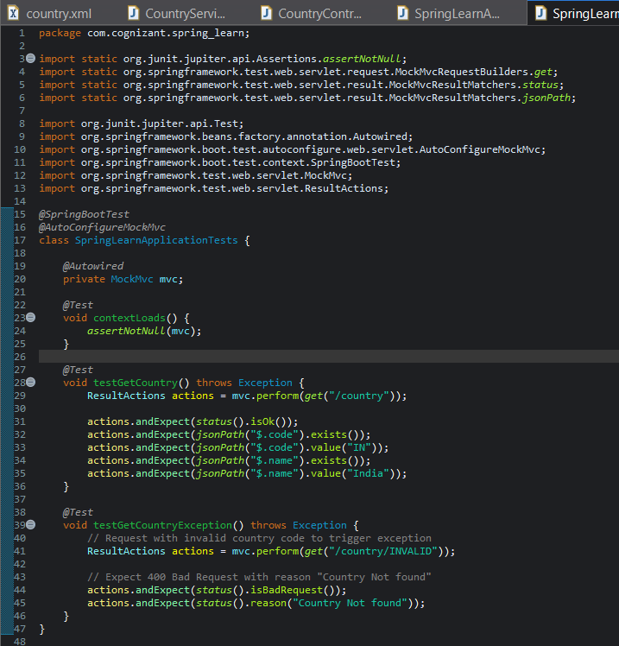

**Output :**

